COMP1821 Coursework

Case Study: Lusail Stadium Management System Update

1-LSEPI

Legal Issues:
• Data Protection: Compliance with Qatar’s Data Protection Law and international standards (e.g., GDPR) in order to protect personal and sensitive data of attendees. Encrypt and anonymize data.
• Liability management: Contracts with vendors must specify clearly who is responsible for malfunctions of a given system. Mitigate risks of unauthorized access, system failures, etc.
• IP Rights: Be mindful of third-party technologies and secure the necessary licenses for the software and patented tools.
• Compliance with accessibility standards: Make sure that the design of the system meets accessibility standards for people with disabilities.

Social Issues:

• Digital divide: Provide alternatives, such as manual registration, for people who don’t have a smartphone, to ensure inclusivity.
• Crowd Management: Install trust through stakeholder engagement; Avoid perceived intrusiveness of surveillance
• Cultural – Build the operation of the system around Qatar’s cultural values to promote community acceptance.
• Job Loss: Provide up-skilling opportunities for the current workforce to facilitate a shift to semi-automated systems, thus reducing anxiety in the general population.

Ethical Issues:

• Transparency: Explain the reason for collecting data and give users control over their personal data.
• Anti-Discrimination:
Very clearly test algorithms thoroughly and make sure the system does not profile users based on ethnicity, age and other biases.
• Surveillance Limits: Use CCTV in proportion to security needs that do not violate attendee’s privacy rights.
• -Environmental Ethics:
Implement sustainable infrastructure to reduce environmental impact

Professional Issues:

• Standards Compliance: Adhere to software engineering practices in place including testing, Agile, and documentation
• Training & Support: Invest in professional development for staff and technical support for attendees to foster ease of transition in using systems.
• Collaborate with Stakeholders: Regularly engage with security teams, event organizers, and users to align system features with real-world needs.
• Budget & Timescale: Complete the work successfully within budget and timescale of £1,800,000 and 18 months.

2-The 5 Ps

(Analyzing the Lusail Stadium Case Through the 5 Ps Framework)

Problem:

What prompted this new project is Mr Jackson, the Senior Director of the leading stadium, desire to implement a new fully fleshed monitorized system with an accompanied software application to help better run their stadium. This is because the current system in place is manually run by staff, being left to manage a wide array of tasks at high efficiency such as managing crowds, Security, Registration, and more, which can results in many misshapes. By taking over the responsibility of carrying out these tasks, the new automated system will help alleviate the load and provide additional functionality for both employees and consumers. There's also requests made by both Mr Morrison, the Director of Stadium management, and Representatives of the stadium, to upgrade the already existing Online systems in place to enhance real time support for the audience while maintaining a welcoming environment for all. To gain insight into the potential of such advancements, the Lusail Stadium in Qatar was used as a benchmark for what an exceptional system can achieve. With the extensive range of services it offers and the inspiring design, a methodical system was implemented to ensure the safety, seamlessness, and comfort of all participants and staffs. By taking inspiration of these noteworthy designs while addressing both operational and technological needs, the upcoming system will incorporate enhanced management functionalities, interactive audience features, and a reinforced monitoring framework, to satisfy all Directors and Representatives goals for the project.

Process:

The V-Model is a linear development methodology pairing each phase with a corresponding testing phase. It emphasizes rigorous planning and documentation, making it reliable for projects with well-defined requirements. However, its rigidity makes it unsuitable for projects where requirements may change, as adapting to unforeseen circumstances often results in costly resource reallocations and delays.

While the V-Model provides a structured approach to define development and life cycle phases, its inflexibility to adapt to changes is its main flaw, requiring overcompensated resources even for minor adjustments.

In contrast, Scrum, part of Agile Software Development, emphasizes adaptability and quick responses to change through iterative “sprints.” These cycles involve developing features, testing results, and refining outcomes to guide future adjustments. Scrum prioritizes product owner involvement, ensuring satisfaction with the final product. However, its flexibility demands a strong commitment from team members, as the project’s success depends on their effective use of the framework.

The V-Model and Scrum differ fundamentally in approach. The V-Model thrives in structured, predictable environments but struggles with dynamic projects like stadium monitoring, where the development cycle and requirements can evolve rapidly. Scrum’s focus on incremental delivery and collaboration enables faster adaptation, making it ideal for large-scale projects. It empowers cross-functional teams, fostering communication and continuous improvement—elements absent in the rigid V-Model.

Scrum’s iterative lifecycle is key to its success. Each sprint includes planning, execution, review, and retrospectives, allowing teams to assess progress and incorporate feedback continuously. This flexibility ensures features like crowd monitoring and app integration align with stakeholder expectations. Roles such as the Scrum Master, ensuring adherence to Scrum principles and the Development Team, executing tasks, demonstrate its collaborative approach. Dividing the project into manageable sprints ensures consistent delivery and high-quality outcomes.

For the stadium project, iterative sprints will address each development phase, starting with analysing current systems to identify deficiencies. The team will design, test, and refine solutions, ensuring functionality at every stage. Each sprint will conclude with a review to incorporate feedback, improving subsequent cycles. Collaboration between the Product Owner, Scrum Master, and Development Team will be crucial to maintaining alignment with project goals. This agile approach allows seamless integration of new systems and ensures the project’s completion within the 18-month timeline and budget.

Project:

The goal of the new stadium monitoring system is to streamline operations, improve audience engagement, and enhance real-time monitoring for safety and efficiency. With an 18-month timeframe, the project will focus on implementing an updated, automated system while training staff to effectively operate the new platform. Key resources include specialized software development teams, system analysts, and training personnel, each crucial to ensuring a smooth transition. Senior management has allocated a budget of £1,800,000 for the analysis, design, and development of the system and accompanying app. This budget will cover software creation, infrastructure upgrades, and staff training. Together, these elements provide a strong foundation for efficient management, security, and interactive stadium experience.

Product:

Our systems are designed for the optimal crowd-management and navigation in stadiums prioritizing security and efficiency. Key features in line include advanced route assistance for mass crowds and emergency rapid response capabilities ensuring smooth and safe movements of participants. By pre-registering and collecting important information such as area, seat, vehicle details, and visit reason, the application improves the organization by allocating seats according to events. The observation system employs RFID and camera access control to monitor visitor movements along with real-time monitoring and alarms to trigger responses towards any suspicious activities. The response plans in case of emergencies shall primarily feature gathering of people safety, followed by orderly evacuation.

People:

The project involved assorted stakeholders, each contributing to its success. Mr. Jackson, the senior director, championed and upheld the project, while Mr. Morrison, the stadium management chief, provided a more cautious viewpoint. Stadium staff will require training to viably use the new systems. The team consisted of mobile app engineers, security pros, IT security specialists, and venture administration specialists. Representatives from different departments, as well as stadium management and security, emphasized crowd control and onlooker safety to form an optimal occasion experience. Each team member's one of a kind point of view and active cooperation led to a bound together exertion.

3-Requirements

Functional Requirements
User Registration
Attendees should be able to register by providing personal informations like name, seat number, zone allocation, and vehicle info. This is important for keep track of everyone and making sure that the event goes smoothly. (Jones, 2020)
Access Control
Only authorized people should access the event. Tools like RFID tags or QR codes helps in verifying who can enter. This makes sure that people who don’t have permissions don’t get in, which is really important for safety. (Smith, 2018)
Live Monitoring
The system should be tracking attendees location in real time. This will help event staffs to control crowds better and keep things safer for everyone.
Emergency Alerts
If there is an emergency, the system need to notify teams like police or medicals as fast as possible. This ensures that help come in time for any serious situation.
Information Updates
Event managers and attendees should can change their details, like seat numbers or zones, if needed. This makes it possible to handle last minute changes without problems.
Real-Time Notifications
Important announcements must sent out to attendees instantly, especially during emergencies. It’s essential that nobody is left out of any critical updates.
Data Handling
The system need to store user data, like registrations and zone assignments, properly. This ensures that information can retrieved easily when required.

Non-Functional Requirements
Performance
The system should work very fast, specially during times like emergencies or high activity like live monitoring. Slow performance can cause lot of problems. (Johnson, 2021)
Scalability
It needs to handle large number of people and data inputs, particularly during big events. Crashes and slowdowns must avoided at all costs.
Ease of Use
The interface should be simple and easy for anyone to use, even people who don’t know much about technology. (Taylor, 2019)
Data Security
Personal information like names, seat details, etc. must be protected using encryption or other secure methods. This will keep hackers or other threats away.
Reliability
The system has to work all the times, specially during important events. Downtime or interruptions could mess up the entire event planning.
Device Compatibility
It needs to work well on both iOS and Android devices so that everyone can access it without issues.
Inclusive Design
It should follow accessibility guidelines to make sure even people with disabilities can use the system without any difficulties.
Error Recovery
The system should have tools to detect and fix errors quickly. If something goes wrong, it should be solved without affecting the event operations. (Brown, 2022)

4-Relationship and Data Flow diagrams

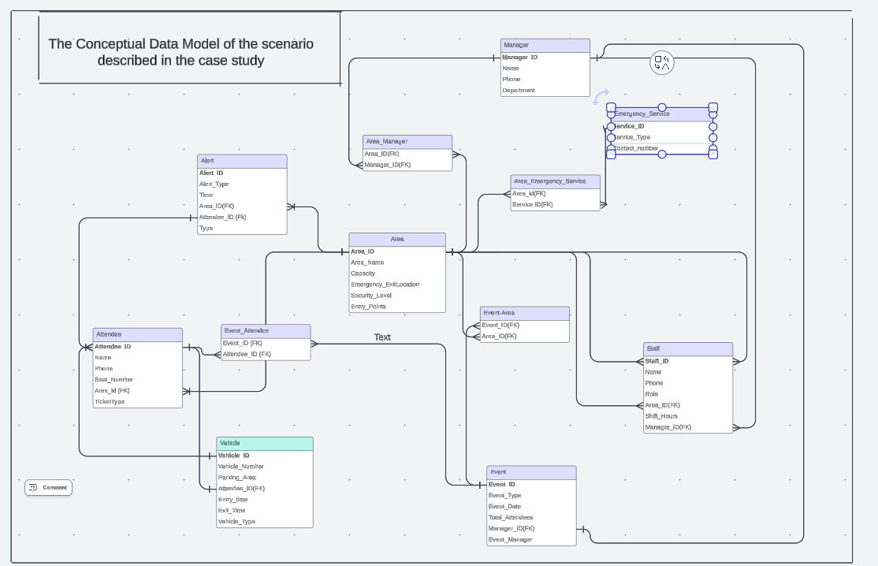
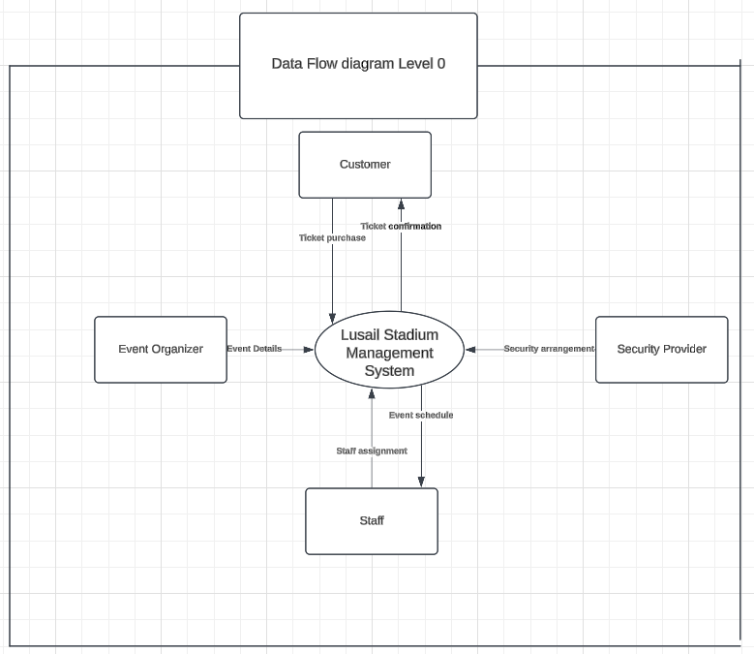

5-Prototype Database

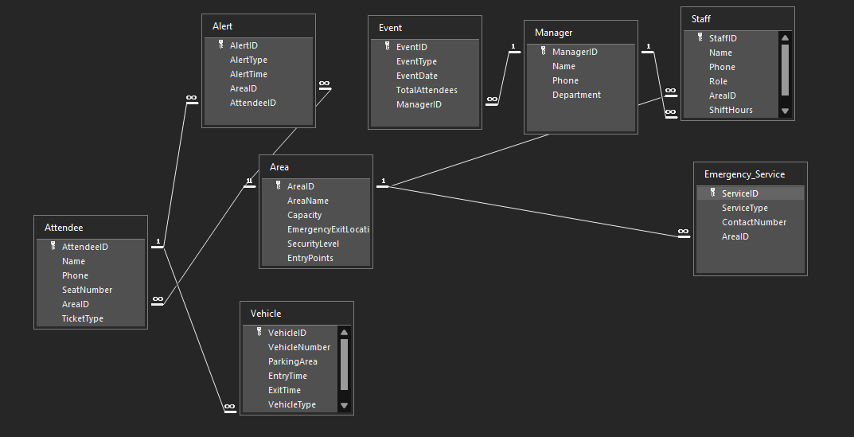

SQL statements for Prototype Database:
Attendee Table :
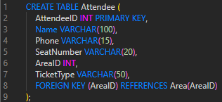
Area Table :
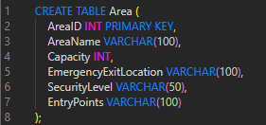

Event Table :
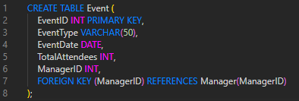
Manager Table :
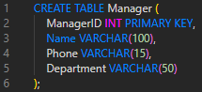
Vehicle Table :
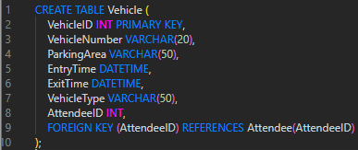
Alert Table :
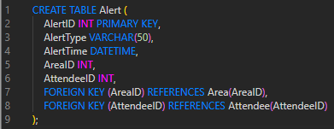

Staff Table :
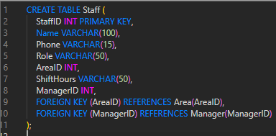
Emergency_Service Table :
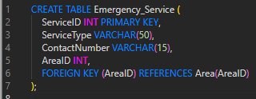

6-UML DIAGRAMS

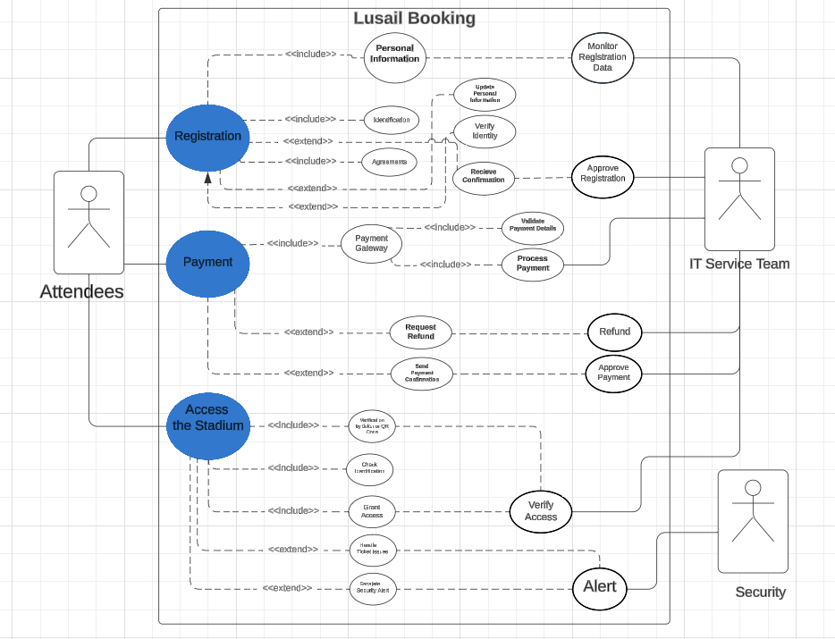
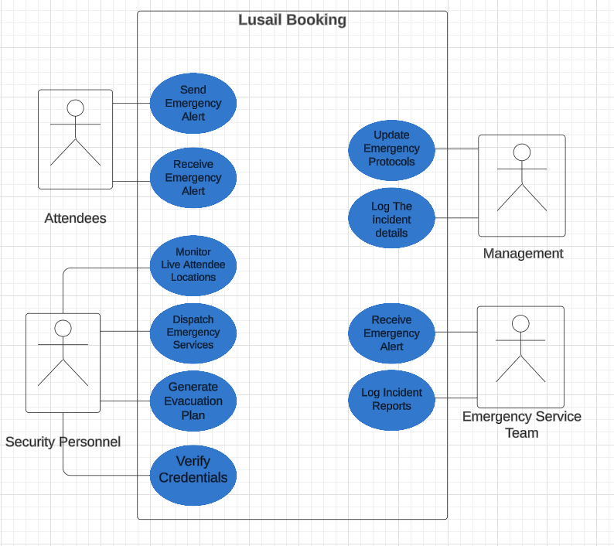

References :
Jones, P., 2020. User Registration Systems: Ensuring Smooth Event Management. Tech System Press.
Smith, R., 2018. Secure Access Control Technologies: Enhancing Event Safety. TechWorld Publications.
Johnson, K., 2021. Real-Time System Performance for Large-Scale Events. Systems Engineering Journal, 45(3), pp.56-65.
Taylor, M., 2019. User-Friendly Interface Design for Non-Tech Users. UI/UX Design Journal, 10(4), pp.12-19.
Brown, A., 2022. Error Recovery Mechanisms in Digital Event Systems. Digital Solutions Magazine, 12(2), pp.18-24.

A completed Self-Assessment form

Group Number: 7
Team member name | Student ID | Individual overall work contribution (%) | Signature
Student 1:  Missaoui Mohamed Ilias | 001350522 | 16.6%
Student 2:  Asfaqur Rahman Siam | 001417337 | 16.6%
Student 3:  Samiul Hoque | 001421408 | 16.6%
Student 4:  Dhari Althunayan | 001425505 | 16.6%
Student 5:  Anna Kanievska | 001410287 | 16.6%
Student 6:  Tanzimul Rafiz Khan | 001396516 | 16.6%
Total work contribution (%) |  | 100

A completed copy of the work breakdown

 | work contribution in %
Describe each task you performed  (For example, the creation of a Use case diagram) | Student 1 | Student 2 | Student 3 | Student 4 | Student 5 | Student 6 | TOTA L
a. Legal, Social, Ethical, and Professional Issues (LSEPI) | 0 | 0 | 100% | 0 | 0 | 0 | 100%
b. The 5 Ps relevant to the given case study | 0 | 0 | 0 | 60% | 40% | 0 | 100%
c. List of functional and non-functional requirement | 50% | 50% | 0 | 0 | 0 | 0 | 100%
d. Developed DFD Design and database | 25% | 0 | 0 | 0 | 0 | 75% | 100%
e. The UML diagrams from Requirement 4. | 0 | 50% | 50% | 0 | 0 | 0 | 100%
f-h. PPT, Report & Results | 25% | 0 | 0 | 25% | 25% | 25% | 100%

- A short personal discussion regarding your role, your contribution within the group and how you liaised with the other team members.
My role within the group was focused on the creation of the Data Flow Diagram which I took great care to design with precision and ensure that it was perfectly aligned with the work of other group members. I put effort into connecting the DFD with other components of the project,
Additionally, as a group, we emphasized the importance of time management and we collectively made sure that every work was completed either during the lab sessions or shortly after, based on the lessons and guidance provided during the lectures. This proactive approach helped us stay on track and avoid last-minute rushes,
Personally, I found the group work experience to be incredibly rewardinga and I enjoyed being part of a team where everyone valued each other's contributions and maintained a positive and productive atmosphere.

Reference List:
Ahmad, P. and Khan, N. (2024) Week 3: Rich Pictures and Use Case Diagrams. [Lecture slides]. University of Greenwich, Principles of Software Engineering Module. Delivered on 5 November.
Taimoor, N. (2024a) Week 1: Introduction and the 5Ps. [Lecture slides]. University of Greenwich, Principles of Software Engineering Module. Delivered on 15 October.
Taimoor, N. (2024b) Week 2: Software Methodologies. [Lecture notes]. University of Greenwich, Principles of Software Engineering Module. Delivered on 22 October.
Jones, P., 2020. User Registration Systems: Ensuring Smooth Event Management. Tech System Press.
Smith, R., 2018. Secure Access Control Technologies: Enhancing Event Safety. TechWorld Publications.
Johnson, K., 2021. Real-Time System Performance for Large-Scale Events. Systems Engineering Journal, 45(3), pp.56-65.
Taylor, M., 2019. User-Friendly Interface Design for Non-Tech Users. UI/UX Design Journal, 10(4), pp.12-19.
Brown, A., 2022. Error Recovery Mechanisms in Digital Event Systems. Digital Solutions Magazine, 12(2), pp.18-24.

